**Fisheries and Oceans Canada (DFO)**

**Data Use Agreement for Data Collected through Joint Partnerships**

The undersigned acknowledges receiving the following data from Fisheries and Oceans Canada (DFO) and the indicated Joint Partner and agrees to the following terms and conditions governing the use of these data. The undersigned further acknowledges that the indicated Joint Partner may be made aware of this request.

Citation: Analysis of tri-axial accelerometer and motion-activated video data affixed to Sablefish longline trap gear

Dataset Creators: A.R. Kronlund, DFO and the Joint Partner: Wild Canadian Sablefish, Ltd.

Dataset Title: Accelerometer, video, and fishing event data collected during the Sablefish Research and Stock Assessment Survey

Dataset Release Date: 21-Jul-2014

Dataset Expiry Date: 21-Jul-2016

Data Set Release Place: Pacific Biological Station, Nanaimo, British Columbia

Project Description Attached? **Yes** / No

1. The above citation shall be used in all references to these data.
2. The data may only be used for the following intended purpose.
3. The data will not be used deliberately to damage the natural environment (e.g., in cases where poaching is a concern).
4. The Dataset Creators shall be invited to review draft publications to ensure that business confidentiality is maintained and to allow for incorporation of comments from the Dataset Creators.
5. Any proposed publication shall be provided to the Dataset Creators prior to public dissemination to allow for incorporation of comments from the Dataset Creators.
6. Permission is required from the Dataset Creators for any other use.
7. Copyright and ownership of the data remains with DFO and the Joint Partner.
8. The data shall not be copied, digitized, scanned, sold, licensed, leased, assigned or given to a third party without the prior approval of the Dataset Creators.
9. The data shall not be included in whole or in part in any commercial products without a licensing agreement with the Dataset Creators.
10. You recognize the limitations of the data and understand that the Dataset Creators do not warrant or guarantee the accuracy, completeness or currency of the data for any specific use.
11. Feedback on obvious mistakes in the dataset must be provided to the Dataset Creators.
12. Use of the data provided is prohibited after the indicated expiry date.

Expected Products and Benefits to DFO:

1. Documentation of analysis in the form of a School of Resource and Environmental Management Project Thesis (REM 699) authored by Client;
2. Copy of all software source code developed for the analysis and permission granted to DFO from the Client for use of the software;
3. Draft of primary publication co-authored by Client, Client academic supervisor, and DFO Personnel who contribute to the data and analyses.

DFO Personnel Name: A.R. Kronlund E-mail: [allen.kronlund@dfo-mpo.gc.ca](mailto:allen.kronlund@dfo-mpo.gc.ca)

Joint Partner Personnel Name: Chris Acheson E-mail: [cacheson@canadiansablefish.com](mailto:cacheson@canadiansablefish.com)

Client Name(s): Beau Doherty E-mail: [beaud@sfu.ca](mailto:beaud@sfu.ca)

Sean P. Cox E-mail: [spcox@sfu.ca](mailto:spcox@sfu.ca)

Address: School of Resource and Environmental Management, Simon Fraser University

8888 University Drive, Burnaby, B.C. V5A 1S6

Telephone: __________________________ Fax: ____________________

Client Signature: __________________________ Date: ____________________

Client Signature: __________________________ Date: ____________________

File Number: N/A Date: ________SQL statement for data extraction attached? Yes / **No**

**Addendum – Client Request and Project Description**

**Impacts of sablefish (*Anoplopoma fimbria*) trap fisheries on corals and sponges in British Columbia: using trap-cameras to record gear-interactions with bottom substrate**

By: Beau Doherty

Research proposal for research project to be submitted for the degree of Master of Resource Management in the School of Resource and Environmental Management (REM) at Simon Fraser University

Supervisor: Sean Cox, Fisheries Science and Management Group, School of Resource and Environmental Management, Simon Fraser University

**Introduction**

What if we could predict the fishing characteristics that would damage sensitive bottom habitats in the ocean? If this were possible, then we could inform more sustainable fisheries that reduce their impact on marine ecosystems, while at the same time potentially improving the productivity of fisheries. Coral (Alcyonacea, Pennatulacea) and sponge (Hexactinellida) communities along British Columbia’s continental shelf and slope provide complex three-dimensional habitat for many commercially important fish and invertebrate populations.

Paradoxically, some fishing gear used to exploit these populations may damage coral and sponge habitats that are important for future fish production (Marliave et al. 2009, Buhl-Mortensen et al. 2010, Baillon et al. 2012). Given that the recovery of these habitats can take decades (Rooper et al. 2011), conservation policies in Canada increasingly aim to protect these habitats from fishing gear.Bottom contact fisheries, such as trawling and dredging, can cause irreversible damage to coral and sponge communities (Kaiser et al. 2006, Andrews et al. 2009). Other bottom contact fisheries that use longlines with baited traps or hooks connected to a groundline on the seafloor are thought to be less damaging because the gear has a smaller footprint and is not intentionally dragged along the bottom (Hourigan et al. 2007).

There is little scientific research assessing trap fishery threats to sessile invertebrate communities (Eno et al. 2001, Coleman et al. 2013), but it is not difficult to imagine circumstances where they can have serious impacts on coral and sponge communities. For instance, strong winds, tides, and currents during trap gear retrieval can cause groundlines to drag along the seafloor, damaging free-standing corals (Stone 2006). Traps landing on corals or sponges can also cause damage when deployed (Coleman et al. 2013) or become entangled during retrieval (Troffe et al. 2005). This raises the question: under what conditions do bottom contact trap fisheries pose threats to deep-water coral and sponge habitats?

**Proposed study system and methods**

Bottom longline traps account for 60-80% of the annual British Columbia sablefish (*Anoplopoma fimbria*) fishery landings (DFO 2005). Over 200,000 individual traps are deployed each year at depths between 450-825 m (DFO 2005), on strings of 50-70 traps attached to a 4-6 km longline. We know that these traps can move during a 24-48 hour soak period and likely drag along the bottom during retrieval.

To reduce harmful gear interactions with bottom habitats we need to understand the extent of this movement and how it is linked to variation in local benthic terrain and currents along the seabed, as well as factors at the sea surface such as winds, tides, vessel speed, hauling direction, and crew experience.

I will use novel deep-water cameras and tri-axial accelerometers affixed to sablefish traps to obtain information on gear-substrate interaction and presence-absence data for corals and sponges along the British Columbia continental shelf. Each camera will be outfitted with a flow meter, temperature probe, compass, and gyroscope sensors to measure *in situ* environmental conditions along with trap orientation and movement during trap sets.

Bathymetry data for most areas on the coast will be obtained from the Pacific Biological Station’s *PBSmapping* database that is available as an R software package. Data on fishing characteristics from the annual sablefish survey (e.g., GPS coordinates of set locations, fishing depths, set lengths, number of traps per set, catch weights, gear deployment and retrieval times) will be obtained from a data request to DFO. Vessel logbook data from the survey will supply information on environmental conditions such as wind speed and wave height.

Cameras and accelerometers were deployed on traps in the annual sablefish surveys completed jointly by Fisheries and Oceans Canada (DFO) and Wild Canadian Sablefish, Ltd. through a Collaborative Agreement in the fall (See Figure 1). The survey is a stratified random design by area and by depth, and will allow for analysis of potential depth and spatial effects of gear movement on coral and sponge distributions.

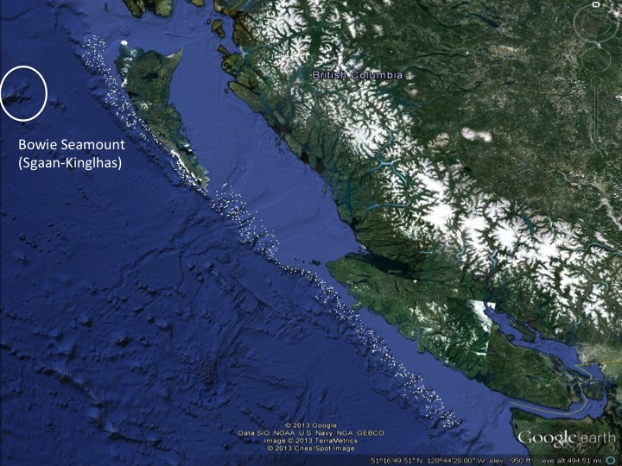

**Figure 1** - Map of sablefish survey locations (shown by white dots) in British Columbia. (Adapted from *Google earth* 2013).

Camera and accelerometers were deployed in various configurations on the 2012 and 2013 DFO surveys, and will also be deployed on the surveys in 2014. Additionally, cameras and accelerometers were deployed on a 2013 commercial fishing trip to Bowie seamount, with plans to collect more data from future commercial fishing vessels. As the fishing behaviour and set deployment along the Bowie Seamount is quite different then sets deployed in DFO’s annual surveys, this will provide a greater variation of spatial and depth information to conduct the analysis.

Video footage from the trap cameras will be analyzed to document the gear behaviour and the species present in the areas fished. It will also provide coral and sponge presence-absence data, which can be used to estimate the frequency of benthic habitats encountered in the sablefish fishery footprint. These data can also be used, along with existing sponge and coral presence-only records from groundfish fisheries (Figure 2), to generate species distribution models for predicting coral/sponge occurrence in relation to environmental variables (Planque et al. 2011).

To analyze the accelerometer data, each set will be separated into three distinct time periods: deployment, soak-time, and retrieval. A multiple regression will be used to test the effects of environmental variables (e.g. bathymetry, wave height, and wind speed) and fishing characteristics (e.g. set length, trap weight, vessel size) on trap movement, using the variance of the total acceleration as a response measure.

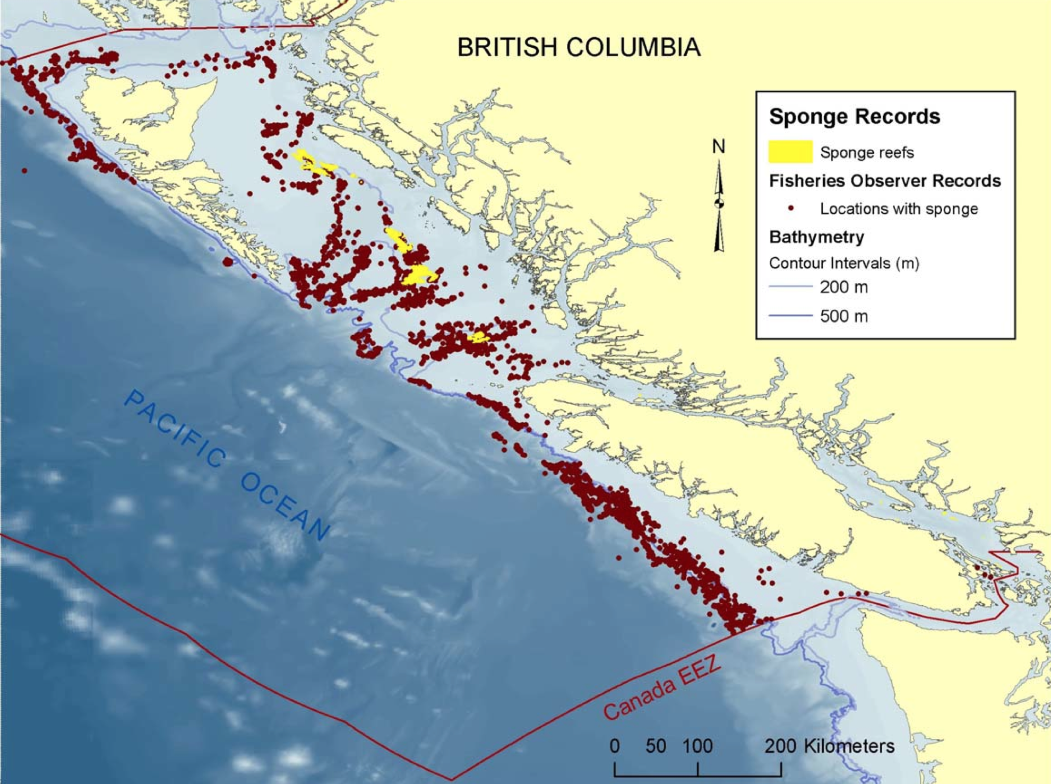

**Figure 2 -** Sponge presence records from groundfish trawl and longline fisheries in British Columbia (Source: Campbell and Simms 2009)

**Expected results**

Previous studies have found that high winds and extreme weather can lead to greater movement of individual fishing traps and significant damage to benthic habitats (Lewis et al. 2009). Similarly, I expect that sablefish trap movement will increase for sets that are retrieved during rough ocean conditions, such as high winds or large waves.

Sablefish fisheries are different than many other trap fisheries as traps are set in deeper waters and much of the fishing takes place during the winter months. There may be some relationship between longline trap movement and depth change throughout the set. The sablefish fishery might also fish in areas where corals and sponges are rare and thus there is much that remains unknown about their potential to damage sensitive benthic habitats.

I suspect that environmental indicators such as bottom current, depth and substrate type will be useful for predicting coral and sponge habitat (Knudby et al. 2013).

**Potential implications**

Predictive models for the distribution of corals and sponges, as well as the behaviour of trap fishing gear, can help B.C. groundfish fishery managers and stakeholders devise specific strategies to reduce risks to sensitive benthic habitat. If successful, this study will be broadly interesting for marine conservation research by demonstrating how a novel *in situ* approach to obtaining observations of coral/sponge presence-absence, fishing gear behaviour, and environmental conditions can be directly integrated into conservation planning for sensitive benthic marine habitats. Success in this study could open the door to increased contributions from the fishing industry in future collection of ecological data.

**Timeline**

The tentative timeline for completion of this research project and the Master’s of Resource Management degree program is 2.5 years (See Figure 3). Accelerometer and video data has already been collected on two DFO sablefish surveys (2012 and 2013) and on one commercial fishing trip to Bowie Seamount (2013), with plans to collect additional data in 2014-2015.

**Figure 3** - Gantt chart describing major steps and timeline for proposed research. Blue bars represent data collection, green bars represent research, data analysis and/or report writing, and the red bar represents course work required to complete the REM program.

**Literature Cited**

Andrews, A. H., R. P. Stone, C. C. Lundstrom, and A. P. DeVogelaere. 2009. Growth rate and age determination of bamboo corals from the northeastern Pacific Ocean using refined 210Pb dating. Marine Ecology Progress Series 397:173–185.

Baillon, S., J.-F. Hamel, V. E. Wareham, and A. Mercier. 2012. Deep cold-water corals as nurseries for fish larvae. Frontiers in Ecology and the Environment 10:351–356.

Buhl-Mortensen, L., A. Vanreusel, A. J. Gooday, L. A. Levin, I. G. Priede, P. Buhl-Mortensen, H. Gheerardyn, N. J. King, and M. Raes. 2010. Biological structures as a source of habitat heterogeneity and biodiversity on the deep ocean margins. Marine Ecology 31:21–50.

Campbell, J., and J. Simms. 2009. Status report on coral and sponge conservation in Canada. DFO, St. John’s, Newfoundland.

Coleman, R., M. Hoskin, E. von Carlshausen, and C. Davis. 2013. Using a no-take zone to assess the impacts of fishing: Sessile epifauna appear insensitive to environmental disturbances from commercial potting. Journal of Experimental Marine Biology and Ecology 440:100–107.

DFO. 2005. Stock Assessment Report on Sablefish (*Anoplopoma fimbria*). Page 8.

Eno, N. C., D. S. MacDonald, J. A. Kinnear, S. C. Amos, C. J. Chapman, R. A. Clark, F. S. P. D. Bunker, and C. Munro. 2001. Effects of crustacean traps on benthic fauna. ICES Journal of Marine Science 58:11–20.

Google earth. 2013. British Columbia. 510 16’ 49.51’’ N 1280 44’ 28.80’’ W Eye alt 492.51 miles. SIO. NOAA. US Navy. NGA. GEBCO. TerraMetrics 2013. http://www.earth.google.com [April 13, 2014].

Hourigan, T., S. Lumsden, G. Dorr, A. Bruckner, S. Brooke, and R. Stone. 2007. State of deep coral ecosystems of the United States: introduction and national overview. Pages 1–64 The state of deep coral ecosystems of the United States. Silver Spring, Maryland.

Kaiser, M., K. Clarke, H. Hinz, M. Austen, P. Somerfield, and I. Karakassis. 2006. Global analysis of response and recovery of benthic biota to fishing. Marine Ecology Progress Series 311:1–14.

Knudby, A., E. Kenchington, and F. J. Murillo. 2013. Modeling the Distribution of Geodia sponges and sponge grounds in the Northwest Atlantic. PloS one 8:e82306.

Lewis, C. F., S. L. Slade, K. E. Maxwell, and T. R. Matthews. 2009. Lobster trap impact on coral reefs: effects of wind-driven trap movement. New Zealand Journal of Marine and Freshwater Research 43:271–282.

Marliave, J. B., K. W. Conway, D. M. Gibbs, A. Lamb, and C. Gibbs. 2009. Biodiversity and rockfish recruitment in sponge gardens and bioherms of southern British Columbia, Canada. Marine biology 156:2247–2254.

Planque, B., C. Loots, P. Petitgas, U. Lindstrøg, and S. Vaz. 2011. Understanding what controls the spatial distribution of fish populations using a multi‐model approach. Fisheries Oceanography 20:1–17.

Rooper, C. N., M. E. Wilkins, C. S. Rose, and C. Coon. 2011. Modeling the impacts of bottom trawling and the subsequent recovery rates of sponges and corals in the Aleutian Islands, Alaska. Continental Shelf Research 31:1827–1834.

Stone, R. 2006. Coral habitat in the Aleutian Islands of Alaska: depth distribution, fine-scale species associations, and fisheries interactions. Coral reefs 25:229–238.

Troffe, P. M., C. D. Levings, G. B. E. Piercey, and V. Keong. 2005. Fishing gear effects and ecology of the sea whip (*Halipteris willemoesi* (Cnidaria: Octocorallia: Pennatulacea)) in British Columbia, Canada: preliminary observations. Aquatic Conservation: Marine and Freshwater Ecosystems 15:523–533.